CANADAGAP

Food Safety certification Workshop for CanadaGAP

fresh fruits & vegetables

    - Do you grow an edible crop?
    - Are you interested in getting your crop food safety Certified?

You are invited to attend a
2-day workshop to learn how to get your growing operation
Certified and find out how to pass a food safety audit.
Date:
Tuesday March 12 and Wednesday March 13, 2019
Time: 9:00 am SHARP to 4:00 pm
How to Register:
Contact: Tysh 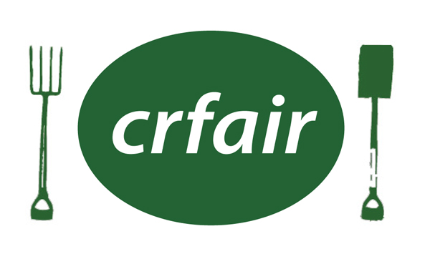
Email: suusan@crfair.ca Phone: 250 514-7999
Location:
Oak Room, Saanich Fairgrounds
1528 Stellys Crossroad, Saanichton, BC V8M 1S8

Benefits of attending this CanadaGAP Workshop are:
- You will learn how to prepare and implement a Good Agricultural Practises program for fruit and vegetable handling, washing and packing, that aligns with the CanadaGAP voluntary food safety certification program.
- Start your CanadaGAP Record Keeping documentation at the workshop
- Learn how a Traceability program supports your MOCK RECALL
- Learn how to apply for funding opportunities through the Canadian Agricultural
Partnership (CAP) programs to support your on-farm food safety (OFFS) practice

